December 2015 Recess & Lunch Playground Schedule
Sunday | Monday | Tuesday | Wednesday | Thursday | Friday | Saturday
 |  | 1 | 2 | 3 | 4  **Noon Dismissal** | 5
6 | 7  10:15-10:45:  11:50-12:50: Gutierrez, k; | 8  10:15-10:45:  11:50-12:50:  Daniels, J; Hoffman | 9  10:15-10:45:  11:50-12:50: Strain; Manzur | 10  10:15-10:45:  11:50-12:50: | 11  10:15-10:45:  11:50-12:50: | 12
13 | 14  10:15-10:45:  11:50-12:50: Gutierrez, k; | 15  10:15-10:45:  11:50-12:50:  Daniels, J; Hoffman | 16  10:15-10:45:  11:50-12:50: Strain; | 17  10:15-10:45:  11:50-12:50: | 18  **Noon Dismissal** | 19
20 | 21  **************** | 22  Chirstmas | 23  Vacation | 24  **************** | 25  Merry Christmas  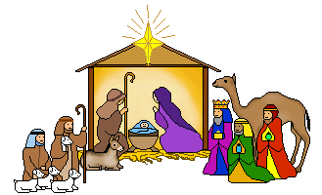 | 26
27 | 28  *************** | 29  **************** | 30  *************** | 31

